Q1 Code
# frozen_string_literal: true
# S1519006 - William Aubrey
# The variable is initialised here for later use in the program, it exists to count the amount of times 'Ruby' appears
rubyCount = 0
# Firstly the code checks to see if the Story1519006.txt file exists within the file system
if File.exist?("./s1519006_submission_1/Story1519006.txt")
# If it is found, it creates a variable of said file and reads it line by line and word by word,
# using a regex to see if the word 'Ruby' exists anywhere in said file, it downcases the words before checking to ensure
# that words checked simply do not have different casing
testFile = File.open("./s1519006_submission_1/Story1519006.txt")
testFile.each do |line|
line.split.each do |word|
if word.downcase =~ /ruby/
rubyCount += 1
end
end
end
# At this point with the ruby count checked, it closes the file. For whatever reason if I do not close and reopen the file
# the line by line display in the next section does not work
testFile.close
testFile = File.open("./s1519006_submission_1/Story1519006.txt")
#If there was any 'Ruby' found, it displays the text line by line and states how many times 'Ruby' was found
if rubyCount > 0
testFile.each do |line|
puts line
end
puts "In the text, there are " + rubyCount.to_s + " counts of 'Ruby'"
else
puts "'Ruby' was not found in the text"
end
# It then closes the file
testFile.close
else
# If the file cannot be found, it states as such as an error
puts "ERROR 1519006 - File does not exist"
end

Q2 Code
# frozen_string_literal: true
# S1519006 - William Aubrey
# The variables are initialised here for later use in the program
path1519006 = ""
name1519006 = ""
# This section asks the user to enter the folder path to check if it exists
# it is protected from users entering nothing
until path1519006 != ""
puts "Enter the path of the folder to check: "
path1519006 = STDIN.gets
path1519006.chop!
end
# This section asks the user to enter the name of the folder to check if it exists
# it is protected from users entering nothing
until name1519006 != ""
puts "Enter the name of the folder to check: "
name1519006 = STDIN.gets
name1519006.chop!
end
# This section of code exists to add a '\' to the end of a folder path in case of situations
# where the user does not include one, such as if they were to copy the folder path from file explorer,
# it then concats the strings together to put them in a readable format for the '.exist?' method
if path1519006 =~ /\$/
path1519006.concat(name1519006)
else
path1519006.concat('/',name1519006)
end
# This section of code checks if the folder path exists, and if so displays the contents of said folder
# The STDIN exists as a simple way to pause the program to wait for an input from the user without using said input
if File.exist?(path1519006)
puts "The folder exists, press enter to view the folders contents"
STDIN.gets
puts Dir.entries(path1519006)
else
puts "ERROR 1519006 - The designated folder does not exist"
end

Results
Q1
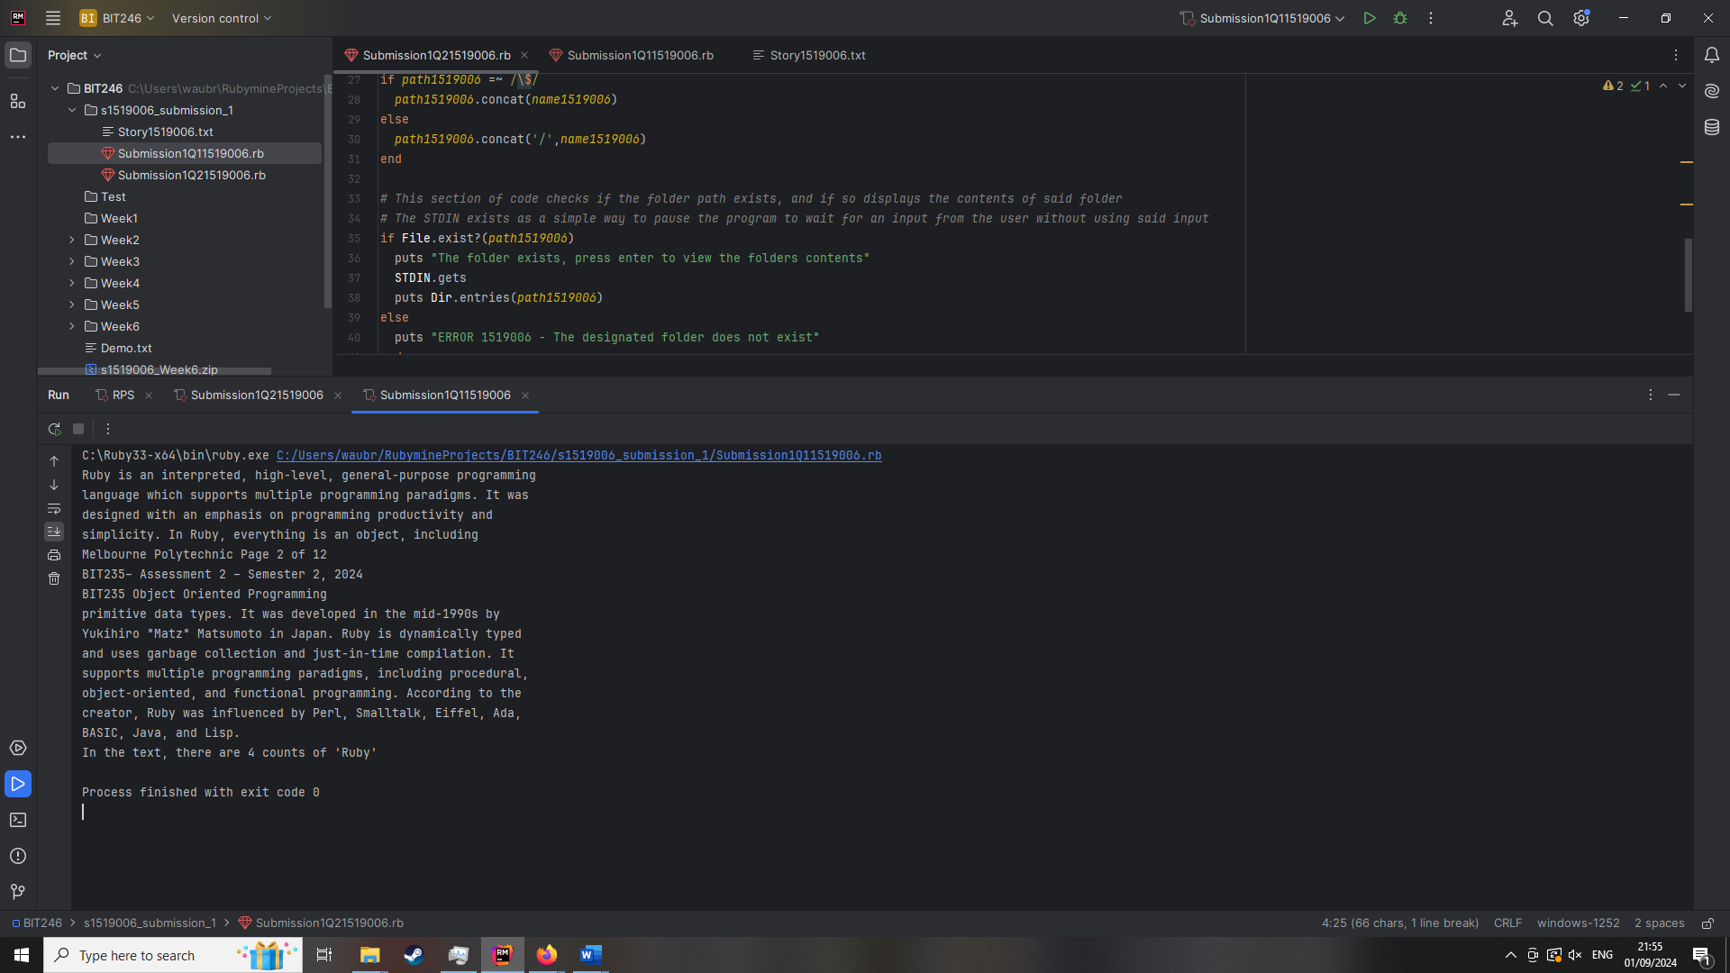
Q2
